CAN

🌐 What Is a CAN?
# Source: AI Source: Provided by: [Data Path: Persons Table -> ID Column: 1, Name_En Column: Motasem Essam] -> From: [ChatGPT] on [12/18/2025]
A Campus Area Network (CAN) is a network that connects multiple Local Area Networks (LANs) within a limited geographic area, such as a university, corporate campus, or industrial complex. It is larger than a LAN but smaller than a MAN (Metropolitan Area Network).

🧠 In Simple Terms:
# Source: AI Source: Provided by: [Data Path: Persons Table -> ID Column: 1, Name_En Column: Motasem Essam] -> From: [ChatGPT] on [12/18/2025]
Think of a CAN as a network of networks within a campus. For example, all the LANs in different buildings of a university (like labs, libraries, and admin offices) are connected to form a CAN.

✅ Key Features of CAN:
# Source: AI Source: Provided by: [Data Path: Persons Table -> ID Column: 1, Name_En Column: Motasem Essam] -> From: [ChatGPT] on [12/18/2025]
- Coverage: Typically spans a campus or a group of nearby buildings.
- Purpose: Connects multiple LANs for sharing resources and communication.
- Ownership: Usually owned and managed by a single organization (like a university or company).
- High Speed: Provides fast data transfer between LANs within the campus.

📶 Examples of CAN:
# Source: AI Source: Provided by: [Data Path: Persons Table -> ID Column: 1, Name_En Column: Motasem Essam] -> From: [ChatGPT] on [12/18/2025]
- University network connecting classrooms, libraries, dorms, and administrative offices.
- Corporate campus network linking offices, data centers, and conference rooms.

CAN vs LAN
# Source: AI Source: Provided by: [Data Path: Persons Table -> ID Column: 1, Name_En Column: Motasem Essam] -> From: [ChatGPT] on [12/18/2025]
- LAN: Small network for one building or location.
- CAN: Larger network connecting multiple LANs within a campus.
- Key Difference: Size and scope—LAN is localized, CAN covers an entire campus.

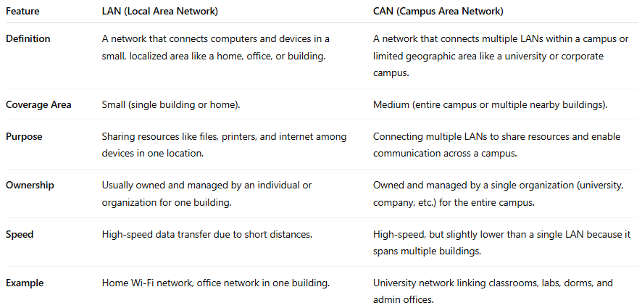
Feature | LAN (Local Area Network) | CAN (Campus Area Network)
Definition | A network that connects computers and devices in a small, localized area like a home, office, or building. | A network that connects multiple LANs within a campus or limited geographic area like a university or corporate campus.
Coverage Area | Small (single building or home). | Medium (entire campus or multiple nearby buildings).
Purpose | Sharing resources like files, printers, and internet among devices in one location. | Connecting multiple LANs to share resources and enable communication across a campus.
Ownership | Usually owned and managed by an individual or organization for one building. | Owned and managed by a single organization (university, company, etc.) for the entire campus.
Speed | High-speed data transfer due to short distances. | High-speed, but slightly lower than a single LAN because it spans multiple buildings.
Example | Home Wi-Fi network, office network in one building. | University network linking classrooms, labs, dorms, and admin offices.

A LAN is a network for a small, localized area, enabling devices to communicate, share resources, and access the Internet quickly. It is ideal for single-building networks, whereas a CAN extends connectivity across multiple buildings within a campus.

Summary:
# Source: AI Source: Provided by: [Data Path: Persons Table -> ID Column: 1, Name_En Column: Motasem Essam] -> From: [ChatGPT] on [12/18/2025]
A Campus Area Network (CAN) links multiple LANs within a campus or organization to allow resource sharing, communication, and efficient network management. It’s larger than a LAN but confined to a single campus or location.

